**Learn about Open Bite – Causes, Problems and Treatment with Damon Smile**

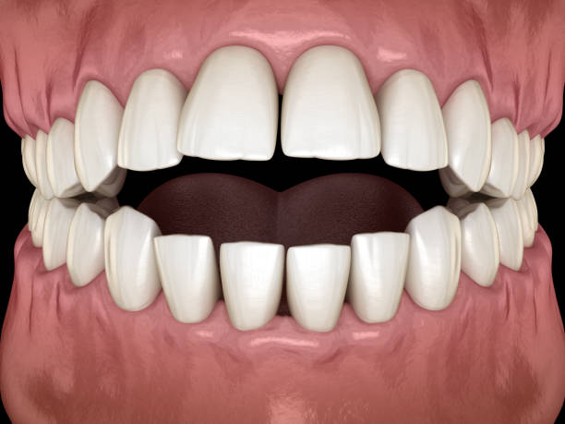

Open Bite is a type of malocclusion, or in other words, misalignment in which the upper and lower teeth at the front bend slightly outwards and do not touch when the mouth is closed. It can be found in both children as well as adults.

**Causes of Open Bite**

Following are some of the main causes of Open Bite:

* An **improper swallowing pattern** is a habit that begins from a very tender age and it is found in a lot of people.
* **Poor tongue posture** can cause pressure on the front upper and lower teeth, leading to deformities and misalignments.
* **Rheumatoid arthritis** or dental arthritis can cause an Open Bite situation, as inflammation and swelling of gums can lead to severe pain and malocclusions of teeth.
* An **injury to the temporomandibular joint (TMJ)** can be a reason leading to the formation of an Open Bite case. Similarly other chronic jaw or dental injuries can lead to forming habits that can eventually cause an Open Bite.
* The **lack of space for adult teeth** to erupt can cause a misalignment with older teeth occupying unnecessary space thus resulting in growth of adult teeth in a misaligned manner.
* **Skeletal Problems** can cause issues as when your jaws grow apart, opposing to growing parallel to each other. Also it is often influenced by genetics.

**How is Open Bite a major problem?**

Open Bite can lead to complications for your teeth, for your overall oral health, and bodily health, not to mention an unaesthetic and unattractive smile. **A malocclusion such as an Open Bite gets worse over time**, which increases the chances of problems like gum disease, or excessive wear and tear of the load-bearing teeth.

**Other problems linked to Open Bite**

Open Bite is a major problem in itself, but is also linked to several other problems. Speech impediments are a common issue with Open Bites, while there is a visible lack of confidence / embarrassment with your smile. In today’s professional age, where your personality and face portfolio are very crucial, it can lead to a negative mark. One may suffer problems or pain with chewing or biting on several occasions over a longer period of time.

Speech impediments, such as a lisp is a major problem directly connected with open bites. There are also various kinds of pain with chewing or biting that arouse due to malocclusions creating irregular biting and chewing habits.

**Treatment of Open Bite**

Open bite in children at an early stage can be treated by behavioral corrections, like stopping certain habits of thumb sucking or pencil chewing. These habits are common in toddlers and children, which lead to developing a case of Open Bite. Checking and stopping these habits can stop the formation of an Open Bite case and the adult teeth later on will not grow in this structure.

The most common way of treating Open Bite is by using braces. With the strengths of its technological advancements, the Damon philosophy believes in treating cases without extractions. Damon Braces have been trusted by over 7 million+ people over 20+ years. Damon braces provide exceptional comfort and treat most cases in lesser time than conventional braces. Damon Smile also offer a variety of options of choosing braces, from metallic to ceramic (almost invisible) braces.

Damon Braces are the perfect solution for this problem.

Contact your nearest Damon Certified Doctor today!

Shine With DamonSmile!